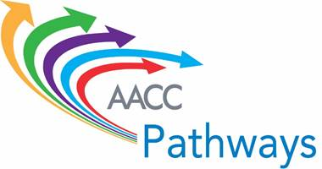

**Monday, October 3: 9:00-10:15 a.m.**

**Table Activity**

**Redesigning the Onramp – The Implications of the Core Principles on Practice**

**Principle 1:** Every student’s postsecondary education begins with an intake process to choose an academic direction and identify the support needed to pass relevant credit-bearing gateway courses in the first year.

**Principle 2:** Enrollment in college-level math and English courses or course sequences aligned with the student’s program of study is the default placement for the vast majority of students.

**Principle 3:** Academic and nonacademic support is provided in conjunction with gateway courses in the student’s academic or career area of interest through co-requisite or other models with evidence of success in which supports are embedded in curricula and instructional strategies.

**Principle 4:** Students for whom the default college-level course placement is not appropriate, even with additional mandatory support, are enrolled in rigorous, streamlined remediation options that align with the knowledge and skills required for success in gateway courses in their academic or career area of interest.

**Principle 5:** Every student is engaged with content of required gateway courses that is aligned with his or her academic program of study—especially in math.

**Principle 6:** Every student is supported to stay on track to a college credential, from intake forward, through the institution’s use of effective mechanisms to generate, share, and act on academic performance and progression data.

**During the next ½ hour, discuss the following with your colleagues from other institutions:**

* What are your institution’s strategies for integrating developmental education into pathways design?
* What is your expected timeline for implementation?
* How will it look in practice for your future students?