The Policy Leadership Trust for Student Success
PURPOSE of THE TRUST &
Overview of the state policy framework
August 22, 2017

Call to Action
After a decade of college completion reform, compelling evidence has emerged on what works to help the most students persist and succeed, especially those who are low-income or underserved. Leading stakeholders from community colleges, state systems, and policy, research, and advocacy organizations have shifted from piloting isolated interventions to designing and implementing unified, connected solutions within and across institutions and systems.
They have embraced guided pathways as a coherent approach to achieving the institutional transformation needed to improve student outcomes. As one of the leading pathway initiatives nationally, the American Association of Community Colleges Pathways Project describes guided pathways in the following way:
The Pathways Model is an integrated, institution-wide approach to student success based on intentionally designed, clear, coherent and structured educational experiences, informed by available evidence, that guide each student effectively and efficiently from her/his point of entry through to attainment of high-quality postsecondary credentials and careers with value in the labor market.
Evidence is emerging on the impact of pathway interventions. Policymakers are beginning to take notice, resulting in a flurry of legislative proposals to codify reform efforts. In this period of rapid innovation and transformation, the question remains, “how can policy help institutions and state systems in the efforts to scale guided pathways?”

mission of the trust
Jobs for the Future (JFF) convenes the Policy Leadership Trust for Student Success (the Trust) to create a more deliberate environment for culling institutional knowledge and evidence to inform policy solutions for improving college completion rates and accelerating achievement for underrepresented students. Intentionally designed to bring together professional staff in system offices and higher education agencies with college leaders, the Trust seeks to ensure community colleges are more effective and efficient by intentionally inserting the experiences of practitioners into state and federal policy dialogues on postsecondary completion. Their perspectives are often missing in the policymaking process.

The mission of the Trust is to advance evidenced-based, practitioner-informed policy approaches that can strengthen pathways to postsecondary credentials of value in the labor market. The Trust develops state and federal policy recommendations and advocates for adoption of these recommendations through (1) strategic outreach to state and federal policymakers, (2) consultation with practitioners in JFF’s 17-state Postsecondary State Policy Network, (3) dialog with the field of practitioners, and (4) thought leadership through the media.

2017 listening tour
In winter and spring 2017, Jobs for the Future embarked on a listening tour to gather the perspectives of individual Trust members on how state policy can help support institutional implementation and scaling of guided pathways. Interviews were conducted with 24 current and former Trust members, representing 10 institutions and 14 systems-level organizations across 13 states with differing governance structures and higher education policy priorities. Several common themes emerged through the listening tour, reflected in the following set of policy design principles and major elements of the state policy framework.

eight design principles for good policy
The policy recommendations of the Trust are based on the following six design principles for how state and federal policy can be most helpful to institutions and state systems in scaling guided pathways and improving student success.
- There are no silver bullets. No single policy intervention will move the needle.
- State context matters when designing policy
  - Political landscape
  - Priorities
  - Governance
  - Capacity
  - Collaboration
  - Current and past reforms
- Policy should flow from practice. Not the inverse.
- Policy is most likely to be implemented with fidelity when practitioners have informed the policy process and have a sense of ownership.
- Good policy creates incentives and structures to catalyze change within institutions and among systems.
- Good policy respects the autonomy of institutions over academic and student affairs.
- Good policy does not prescribe rigid implementation of practices and models.
- High-level directives can be useful at times in steering the direction of reform, deepening commitment, overcoming resistance, and creating leverage.

state pOLICY framework
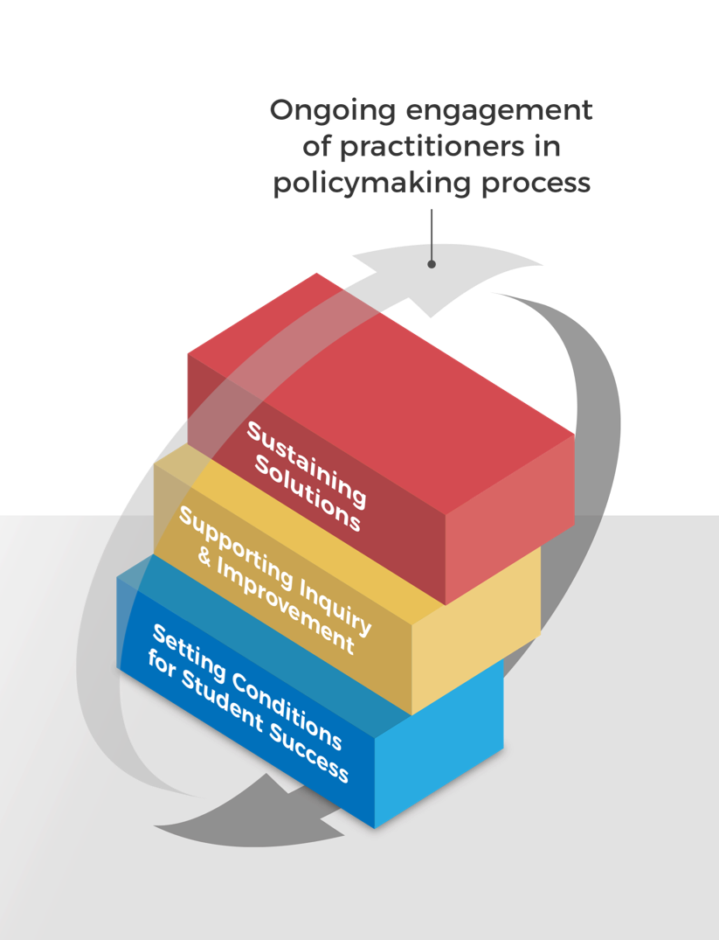
As an essential first step, policymakers should establish key metrics, funding incentives, and set expectations for systems integration and employer engagement. With these essential incentive structure in place, the Trust recommends that policymakers should build state and institutional capacity to identify key barriers to student success and implement key solutions, related to guided pathways. This is represented in the middle block “supporting inquiry & improvement.” Only after institutions and state systems have sufficiently scaled pathway reforms would the Trust recommend codifying practices into policy may be appropriate. Doing so would help to sustain and scale momentum. In each of the three phases, the Trust recommends that policymakers actively engage practitioners in the design of policy to ensure that policy is informed and supportive of good practice on the ground

See below for detailed policy recommendations for each phase of the framework.

Setting conditions for Student success
- Establish statewide goal for increasing attainment rates of credentials of value.
- Establish key performance indicators to track momentum, completion, transfer, and employment outcomes.
- Reward institutions and systems for student success.
  - Align funding to key metrics and strategic priorities
  - Emphasize equity and economic mobility in funding decisions
  - Incentivize systems change and alignment
- Foster cross-sector collaboration between K-12, community colleges, and universities in designing clearer paths to postsecondary credentials and employment. Establish process, roles and responsibilities, and deadlines for institutions and systems to develop:
  - Statewide transfer pathways and policies
  - Differentiated math pathways
  - Align to dual enrollment course offerings and other on-ramps (e.g. adult education and development education) to guided pathways, especially transfer-bound programs of study.
- Foster cross-sector collaboration to bolster financial stability of students to alleviate their financial hurdles to completion.
  - Incentivize local partnerships among institutions and health and human services agencies
  - Braid federal and state funding of health and human services with postsecondary resources for non-academic supports (e.g. emergency aid, wraparound services)
  - Streamline access to public benefits
  - Preserve need-based financial aid
  - Create financial incentives for completion (e.g. transfer grants)
- Deepen engagement and responsiveness to business and industry needs.
  - Meaningful engagement of employers to inform decision-making (e.g. Industry-led sector partnerships)
  - Use of real-time and traditional labor market information to inform decision-making
  - Investment and alignment with work-based learning

supporting inquiry and improvement
- Invest in data capacity
  - Support a culture of inquiry by enhancing data capacity and encouraging use of data to identify barriers to student success and inform decision-making on implementation of solutions.
  - Establish/enhance state-level longitudinal data systems to track student progress across K-12, workforce, and higher education systems and institutions
  - Ensure data is disaggregated by readiness, race, and socioeconomic status to safeguard equity
- Invest in statewide infrastructure for scale. Develop state-level capacity to:
  - Convene institutions to facilitate peer exchange and buy-in of evidence-based solutions to barriers
  - Deploy expert practitioners to provide guidance to institutions undertaking reforms
  - Help practitioners understand the implications and opportunities of policies in place
  - Broker technical assistance from national organizations to support institutions in strategic planning, design, and implementation of solutions
- Enhance institutional capacity to identify barriers to student success and implement needed reforms through additional resources to:
  - Defray upfront costs of implementing guided pathway practices (e.g., hiring additional advisors)
  - Purchase and integrate technology tools
  - Enhance institutional capacity for data analysis
  - Support campus planning and implementation of pathway reforms
  - Provide professional development for faculty and advisors in support of student success efforts
- Remove policy barriers to implementing guided pathway practices.
  - Ensure sufficient flexibility for institutions to experiment with implementing evidence-based solutions (e.g., accelerating developmental education, using multiple measures for placement, or instituting an integrated approach to academic advising and career counseling)

sustaining solutions
- Conduct formative and summative evaluations of implemented practices, especially before considering codifying practices in policy
- Establish formal opportunities for practitioners to inform policy design and rule making.
- Strive for continuous improvement.
  - Over time, evaluate impact of goals, metrics, incentives, capacity building, engagement strategies, and policy adoption. Make appropriate adjustments to bolster scaling of guided pathways.

Appendix

current members of the trust
Co-Chairs
- Scott Ralls, Northern Virginia Community College
- Marcia Ballinger, Lorain County Community College
Members
- Julie Alexander, Miami Dade College
- Michael Baston, Rockland Community College
- Peter Blake, State Council of Higher Education for Virginia
- Lisa Chapman, North Carolina Community College System
- Tamara Clunis, Amarillo College
- Tristan Denley, University System of Georgia
- Johanna Duncan-Poitier, State University of New York
- Maria Harper-Marinick, Maricopa Community Colleges
- Maria Hesse, Arizona State University
- Jack Hershey, Ohio Association of Community Colleges
- Jon Kerr, Washington State Board for Community and Technical Colleges
- Kenneth Klucznik, Connecticut State Colleges & Universities
- Mike Leach, Arkansas Community Colleges
- Sharon Morrissey, Virginia Community College System
- John Morton, University of Hawai’i Community Colleges
- Lawrence Nespoli, New Jersey Council of County Colleges
- Peter Quigley, University of Hawai’i Community Colleges
- Richard Rhodes, Austin Community College District
- Mary Rittling, Davidson County Community College
- Karen Stout, Achieving the Dream
- Debra Stuart, Oklahoma State Regents for Higher Education
- Tonjua Williams, St. Petersburg College
- Jan Yoshiwara, Washington State Board for Community and Technical Colleges

EVOLVING LIST OF ADVISORS
- Michelle Cooper, Institute for Higher Education Policy
- Nikki Edgecombe, Community College Research Center
- Melissa Henderson, Educate Texas
- Robert Johnstone, National Center for Inquiry & Improvement
- Hana Lahr, Community College Research Center
- Mary Alice McCarthy, New America Foundation
- Kay McClenney, American Association of Community Colleges
- Tia McNair, Association of American Colleges & Universities
- Christopher Nellum, Policy & Research Director, Young Invincibles
- Lashawn Richburg-Hayes, formerly with MDRC
- Douglas Shapiro, National Student Clearinghouse Research Center
- Martha Snyder, HCM Strategists
- Uri Treisman, Charles A. Dana Center

for more information
Contact
David Altstadt, Senior Program Manager
Jobs for the Future
daltstadt@jff.org

