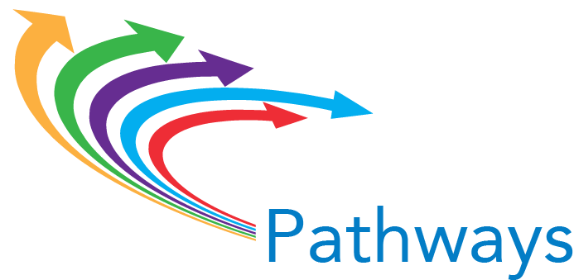

Institutional Case Statement for Guided Pathways at Scale

Instructions: With your college team, develop a “case statement,” answering the question, “What is the evidence and the experience that convince us it is both urgent and important to commit to work as challenging and transformational as implementing guided pathways at scale, for all of our students? Maximum length: 750 words.

GUIDED PATHWAYS AT SCALE: CASE STATEMENT FOR [YOUR INSTITUTION]

