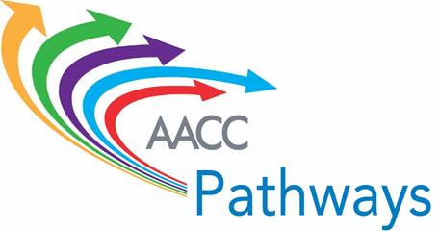

**Institute #5 -- Pathway Design II: Pathways to Transfer and Employment**

**Advance Work Overview**

1. **Advance Work Reading --** [**The Transfer Playbook: Essential Practices for Two- and Four-Year Colleges**](https://assets.aspeninstitute.org/content/uploads/2016/05/aspen-ccrc_transferplaybook_05-2016.pdf)

Have all members of your core team read the Aspen Institute and CCRC authored Transfer Playbook.

1. **The Transfer Playbook: Tool for Assessing Progress toward Adoption of Essential Transfer Practices for Community Colleges**

After reading the *Transfer Playbook*, convene your pathways team and as a group, complete the *Tool for Assessing Progress toward Adoption of Essential Transfer Practices for Community Colleges.* Once a diverse, inclusive core team has completed the assessment, members should then engage others at the institution in conversation about the results, beginning with the president and her/his cabinet and followed by a broader group of faculty and staff. Ideally these discussions should help refine the assessment, build shared understanding of the ways your college does and does not support transfer students, and motivate college leaders to continue to engage the wider college community in planning and implementing improvements.

The assessment is organized around four categories of essential practices: (1) prioritize transfer; (2) create clear, rigorous program pathways; (3) provide tailored transfer advising; and (4) build effective transfer partnerships. Within the four categories, please use the following scale to rate how systematically each sub-practice is implemented at your college. **By “systemic,” we mean that the practice is implemented routinely and at scale, and that it is part of the regular operation and culture of the college.** The tool offers questions to consider as you conduct the assessment, and space to identify possible next steps and anticipated challenges.

1. **Transfer and Employment Program Mapping Template**

Use the template to map the relationships between programs in a particular meta-major and related jobs and further education opportunities. Complete the template and the schematic for the institution’s **top three** meta-majors by enrollment.

1. **Measuring Your College’s Effectiveness Serving Transfer Students Data Template – Using National Student Clearinghouse Data**

The tables and definitions in the template provided are a basic set of metrics the institution can compute using National Student Clearinghouse data to measure the outcomes of your students who seek to transfer to a four-year institution. Table 1 presents overall measures of your college’s transfer outcomes in comparison to national averages and top colleges, and Table 2 shows how your transfer students fare at your college’s top five transfer destinations.

If your institution does not participate in National Student Clearinghouse data collection, please contact Gretchen.

**Note: For this Institute, the Short-term Action Plan does not require work in advance. It will be used as a working document during the team sessions at the Institute in Ft. Lauderdale. We will send the Short-term Action Plan template to the team facilitators in early June.**

**If there are any questions about the submission of the advance work, please contact Gretchen Schmidt (**[**gschmidt@aacc.nche.edu**](mailto:gschmidt@aacc.nche.edu)**) or Coral Noonan-Terry (**[**noonan@cccse.org**](mailto:noonan@cccse.org)**). If you have any questions about the transfer templates or data submission, please contact John Fink (**[**john.fink@tc.columbia.edu**](mailto:john.fink@tc.columbia.edu)**).**