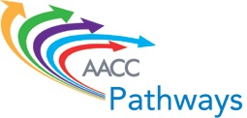

**Pathways Institute #3**

**Redesigning Student Intake and Support Systems**

**Advance Readings**

1. Core Principles for Transforming Remediation within a Comprehensive Student Success Strategy: <http://www.core-principles.org/>
2. When College Students Start Behind: <https://s3-us-west-2.amazonaws.com/production.tcf.org/app/uploads/2016/05/01205852/TCF_WhenCollegeStudentsStartBehind.pdf>
3. Is Corequisite Remediation Cost-Effective? Early Findings From Tennessee: <http://ccrc.tc.columbia.edu/publications/corequisite-remediation-cost-effective-tennessee.html>
4. How Colleges Use Integrated Planning and Advising for Student Success (iPASS) to Transform Student Support: <http://ccrc.tc.columbia.edu/publications/how-colleges-use-ipass-transform-student-support.html>
5. Leadership for Transformative Change: Lessons From Technology-Mediated Reform in Broad-Access Colleges: <http://ccrc.tc.columbia.edu/publications/leadership-for-transformative-change.html>